Lab 5: Authentication Vulnerabilities (other authentication mechanisms)
Objective:
- In this section, we'll look at some of the supplementary functionality that is related to authentication and demonstrate how these can be vulnerable.
In this lab, students need to:
- Perform two challenges:
  - Brute-forcing a stay-logged-in cookie
  - Offline password cracking
- Explain and capture all steps (full windows screen capture).

Submit a report addressing all the questions mentioned above in either PDF or Markdown format. Additionally, include a video demonstrating the detailed process of your work to ensure the authenticity of your lab exercise.
The report file name must be Class_YourStudentID _YourName_Lab5
1. Brute-forcing a stay-logged-in cookie
This image displays the Web Security Academy lab “Brute-forcing a stay-logged-in cookie” login page where the user logs in as wiener with the “Stay logged in” option enabled. Burp Suite is running on the left, capturing the HTTP traffic, including the login request and server responses. This step is used to identify the authentication request and the persistent login cookie for further analysis.
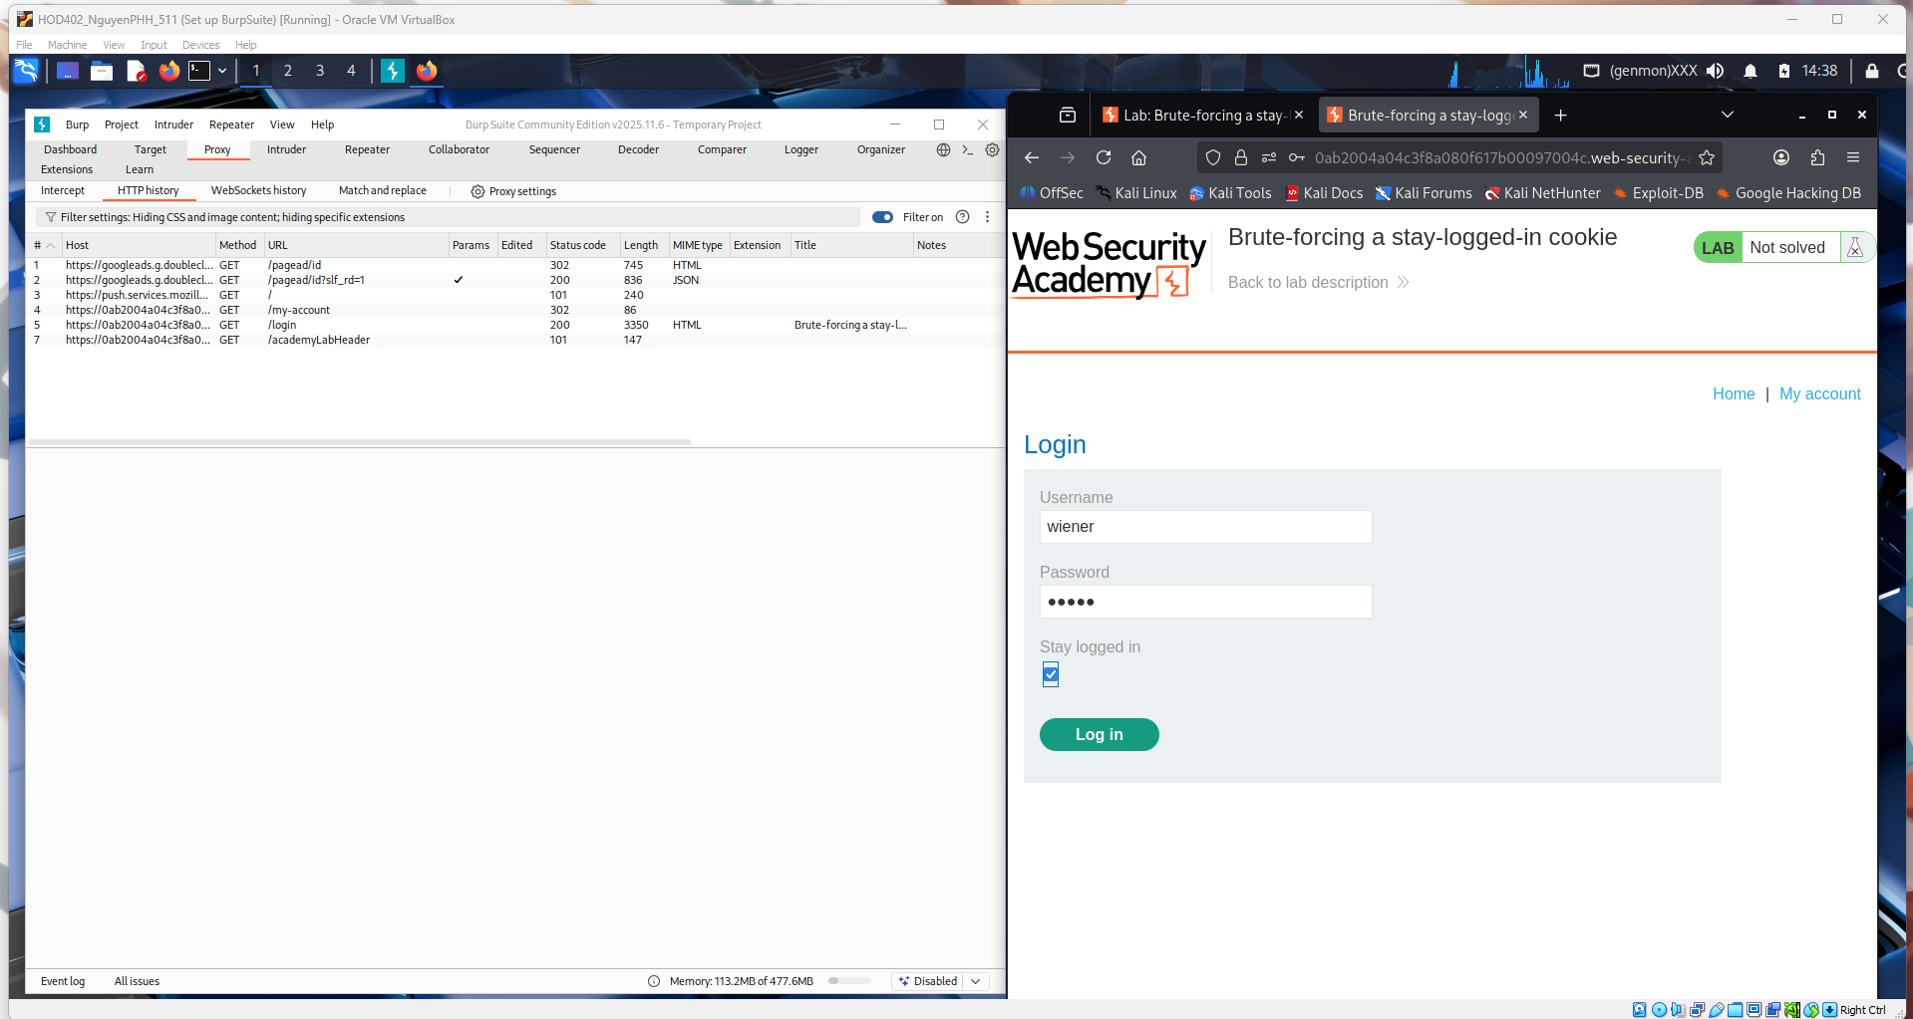
This image shows the successful login process after submitting the credentials with the “Stay logged in” option enabled. In Burp Suite, the POST /login request and its 302 Found response are visible, where the server sets cookies including the persistent login cookie. The browser is redirected to /my-account, confirming authentication and that the stay-logged-in cookie has been issued for further analysis.
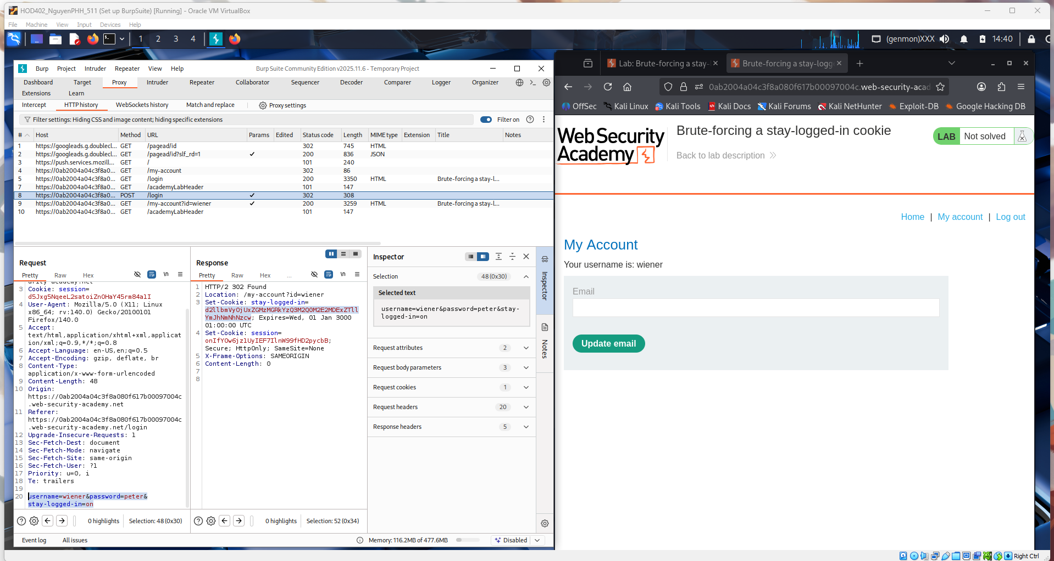
This image illustrates the analysis of the stay-logged-in cookie using Burp Suite Decoder. The cookie value is decoded from Base64, revealing the format username:hash, which in this case shows wiener followed by a hashed value. This confirms that the persistent login cookie contains predictable data that can be targeted for brute-forcing.
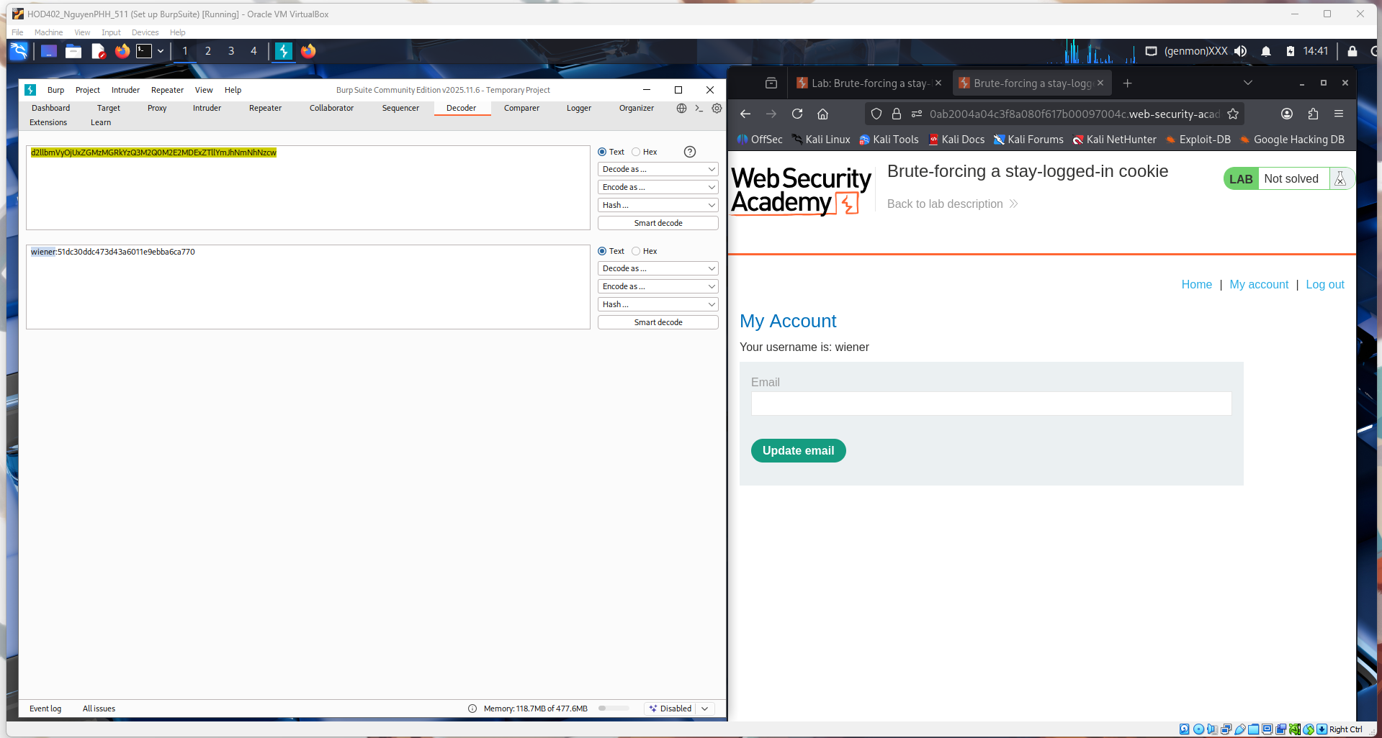
This image demonstrates cracking the hash extracted from the stay-logged-in cookie. After decoding the cookie in Burp, it is revealed to follow the format Base64(username:md5(password)). The MD5 hash is then submitted to CrackStation, which successfully reveals the plaintext password “peter.” This shows that the persistent login cookie relies on a weak, crackable hash, making it vulnerable to brute-force attacks.
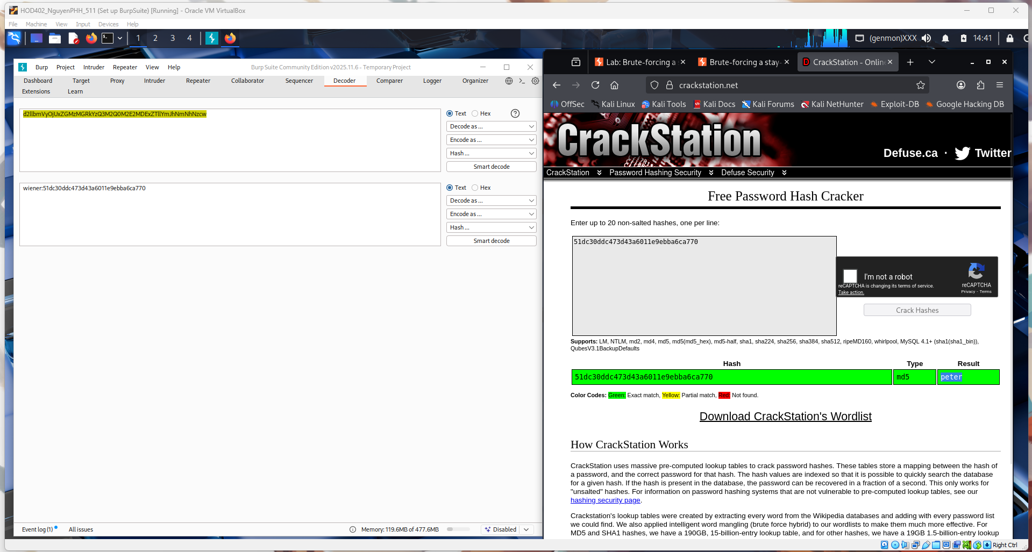
This image shows the use of the modified stay-logged-in cookie to access another user’s account. In Burp Suite, the request includes the crafted cookie containing the new credentials, and the server responds with a 200 OK, indicating successful authentication. The browser displays the authenticated page, confirming that the forged cookie works and the account has been accessed.
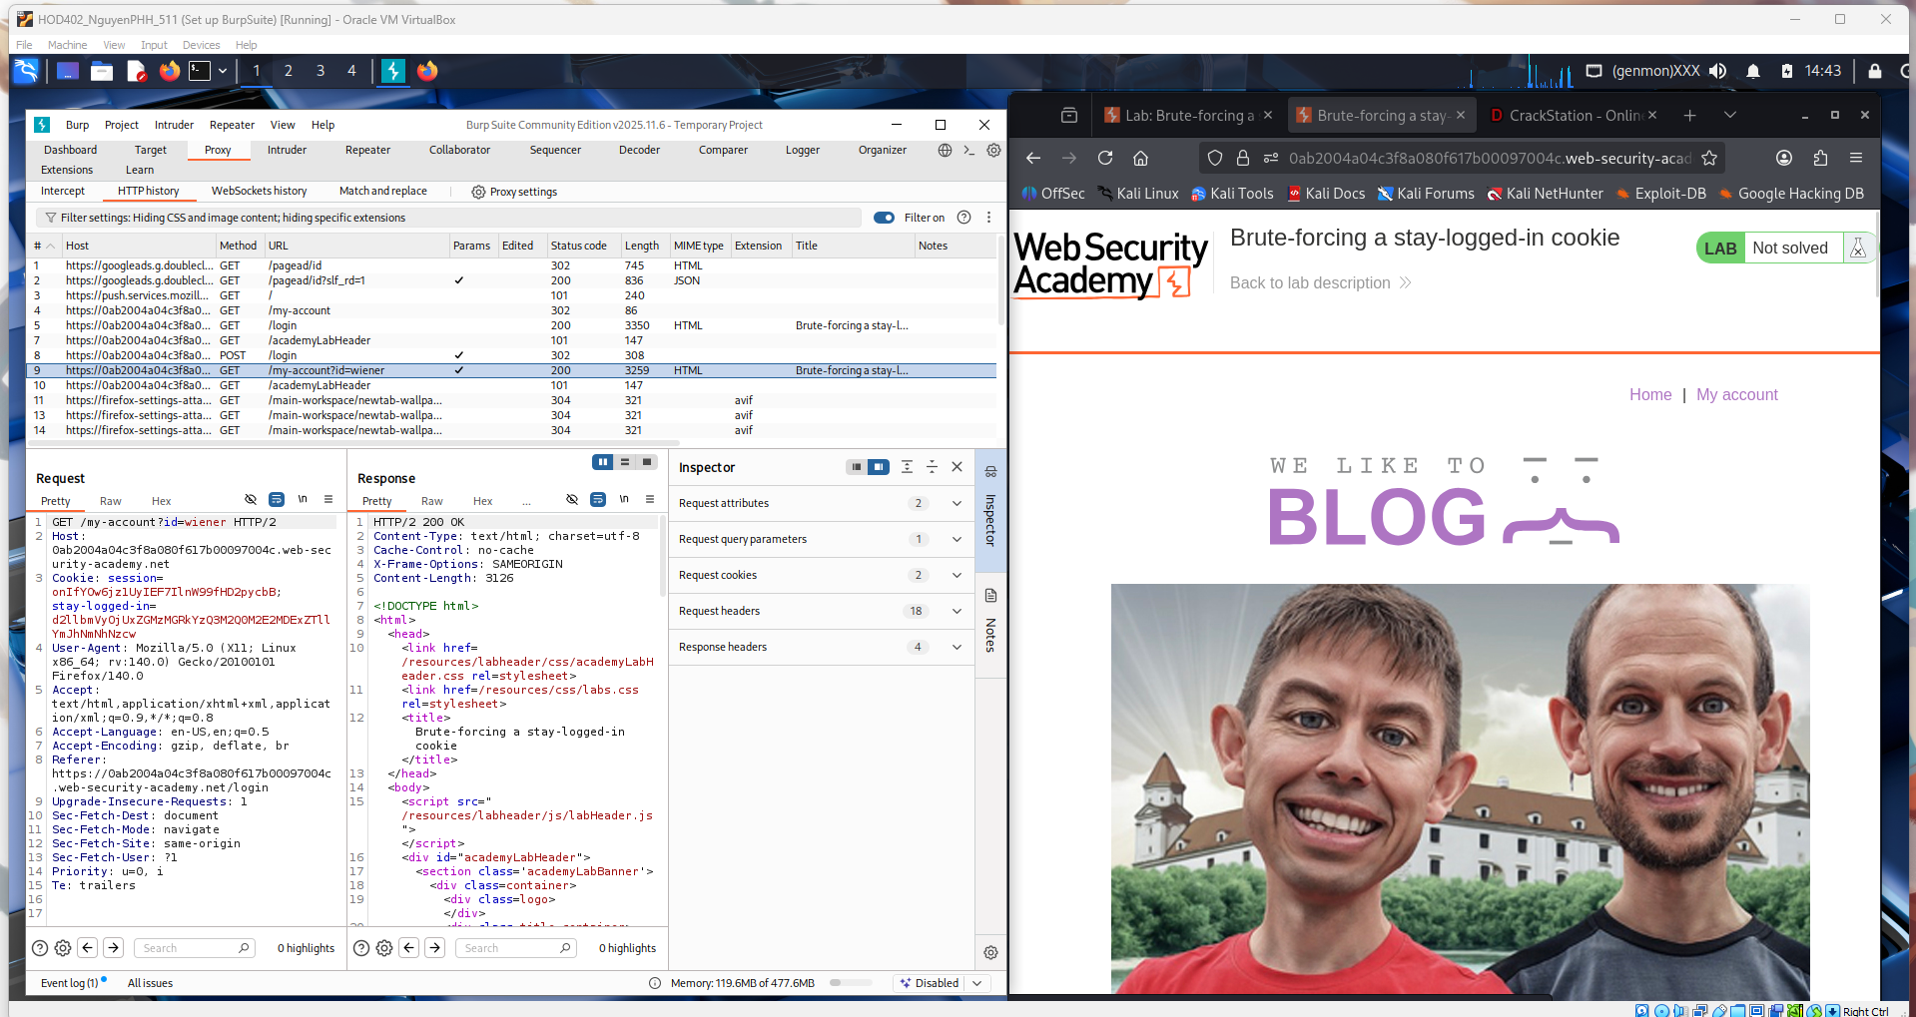
This image shows the preparation phase for brute-forcing the stay-logged-in cookie using Burp Intruder. The request containing the persistent login cookie is loaded into Intruder, and the payload position is set on the hashed password portion. On the right, the PortSwigger password list is open, which will be used as the wordlist to generate MD5 hashes for testing different password values.
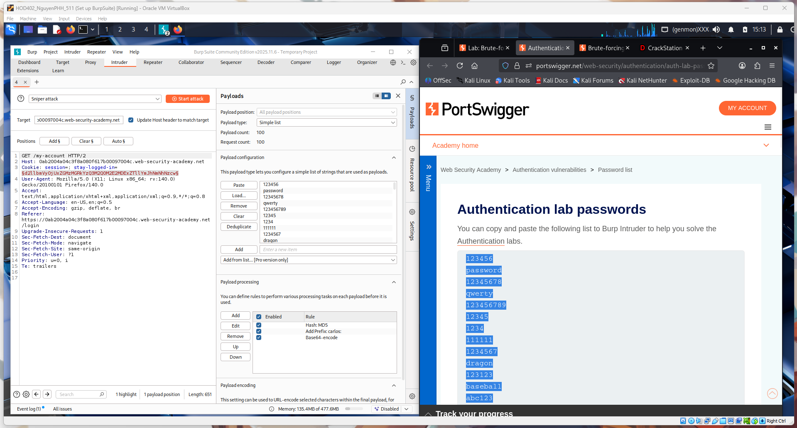
This image shows the Burp Intruder attack in progress against the stay-logged-in cookie. Multiple payloads are being tested, and the results table displays differences in status codes and response lengths, which help identify a successful login attempt. The request panel below shows the modified cookie being sent with each attempt, confirming that the hash value is being brute-forced.
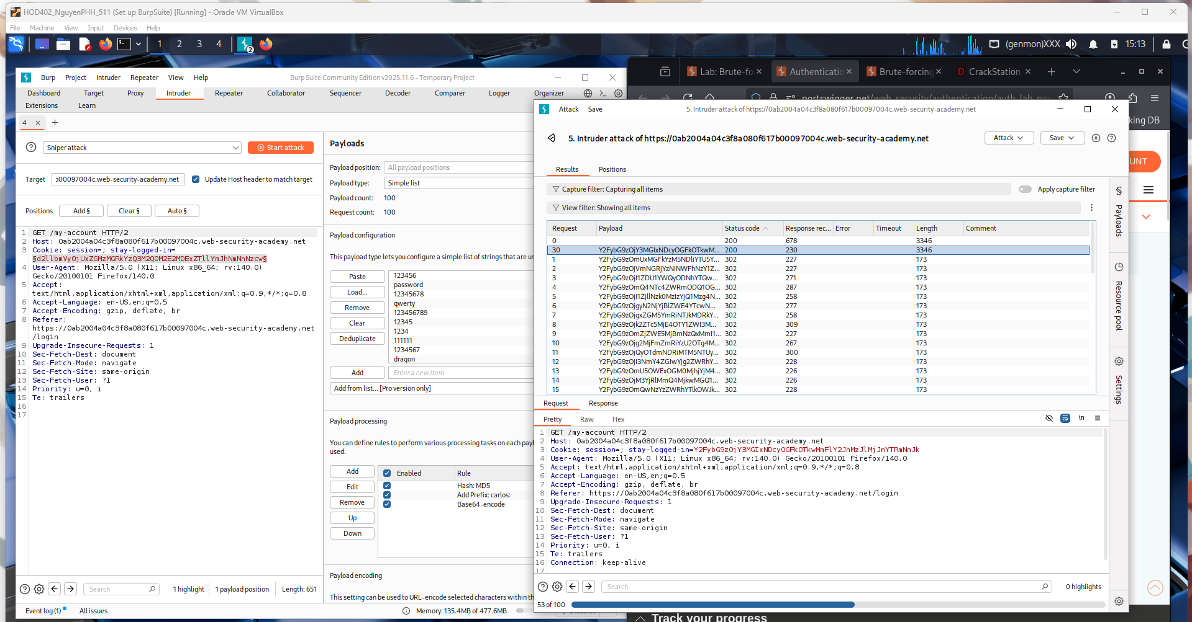
This image shows the identification of the correct payload during the Intruder attack. One request stands out with a different status code and response length, indicating a successful authentication. The user right-clicks this result to send it to other Burp tools (such as Repeater) for further verification and analysis of the valid stay-logged-in cookie.
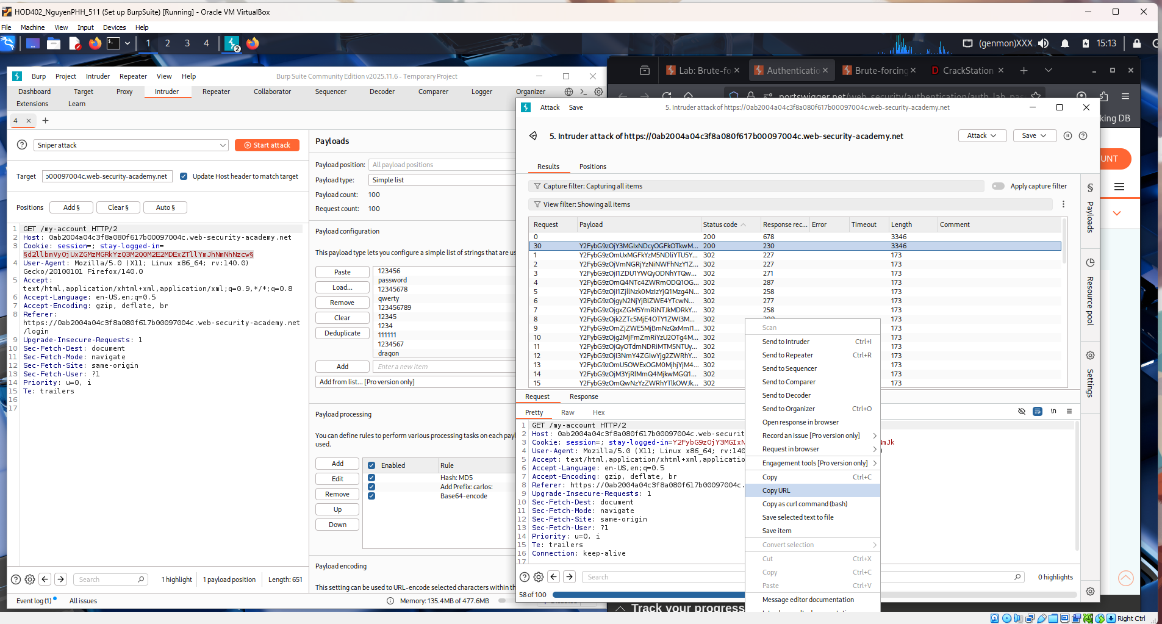
This image shows the successful result of the brute-force attack on the stay-logged-in cookie. A specific payload produces a different response, indicating valid credentials, and the request with the correct cookie is confirmed. The browser displays the account page along with the “Congratulations, you solved the lab!” message, proving that the forged cookie allowed full authentication.
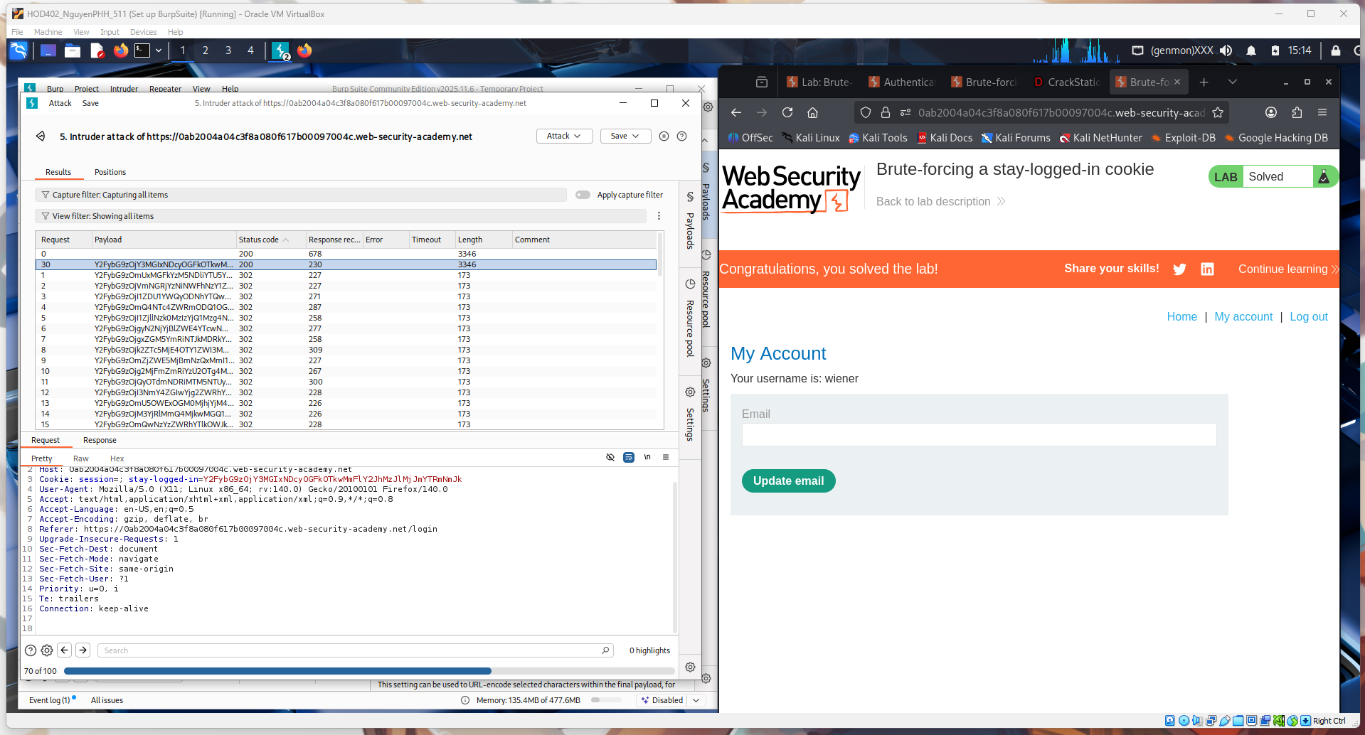
Conclusion – Brute-forcing a Stay-Logged-In Cookie:
In this lab, we exploited a weak “stay logged in” cookie that was used for authentication. By analyzing the cookie structure and performing a brute-force attack, we were able to guess valid values and gain unauthorized access to another user’s account without knowing their password.
This demonstrates that authentication tokens must be unpredictable and securely generated. If cookies rely on guessable data (like usernames or weak hashes), attackers can bypass login systems. Secure session management, strong cryptographic tokens, and proper validation are necessary to protect against this vulnerability.

2. Offline password cracking
This image shows the login page of the Offline password cracking lab where the user logs in as wiener with the “Stay logged in” option enabled. Burp Suite is capturing the POST /login request and server response in the HTTP history. This step is used to obtain the authentication cookies, which will later be analyzed and cracked offline.
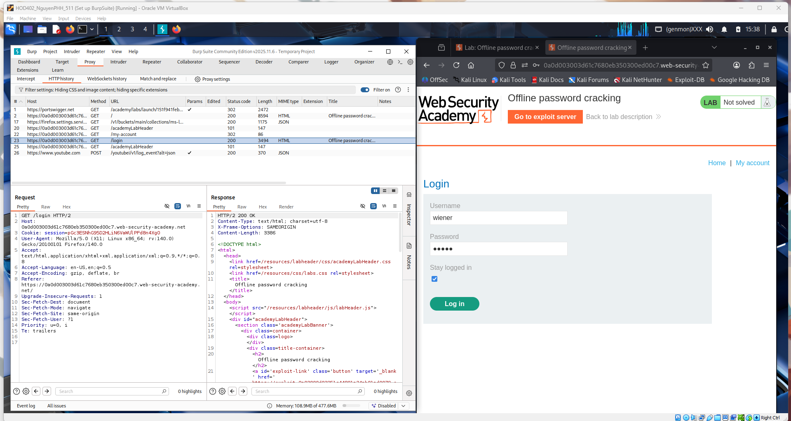

This image shows the successful login response captured in Burp Suite for the Offline password cracking lab. The POST /login request returns a 302 redirect to /my-account, and the server sets cookies including the stay-logged-in token. This cookie will be extracted and analyzed offline to recover the user’s password.
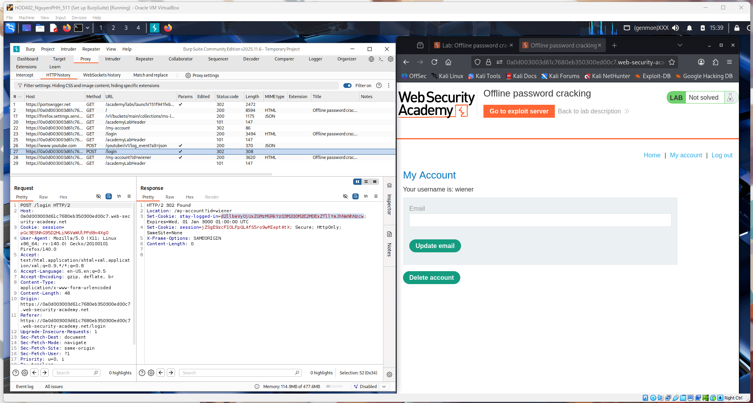
This image shows the stay-logged-in cookie being analyzed in Burp Decoder during the Offline Password Cracking lab. The cookie value is decoded from Base64, revealing the structure username:hash, where the hash corresponds to the user’s password. This extracted hash will be taken offline and cracked using external tools.
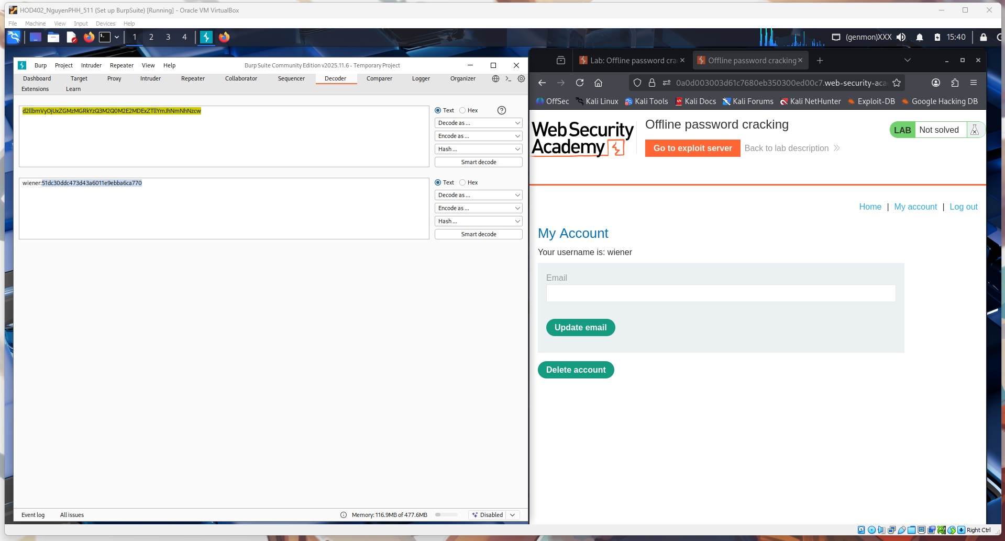

This image shows the offline cracking process of the password hash extracted from the stay-logged-in cookie. The hash is submitted to CrackStation, which identifies it as an MD5 hash and reveals the plaintext password “peter.” This confirms that the cookie uses a weak hashing mechanism that can be cracked outside the application.
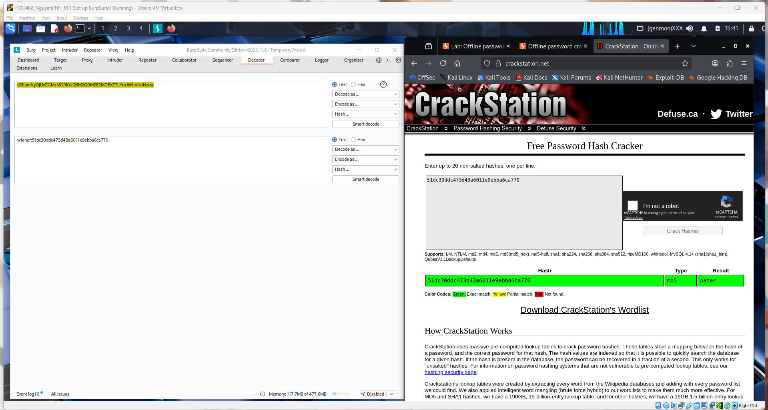
This image shows access to another user’s content after cracking the password offline. Using the recovered credentials, the attacker can view a blog post titled “I’m A Photoshopped Girl Living In A Photoshopped World”, confirming unauthorized access. This demonstrates how weak hashing in authentication data can lead to full account compromise once the password is cracked.
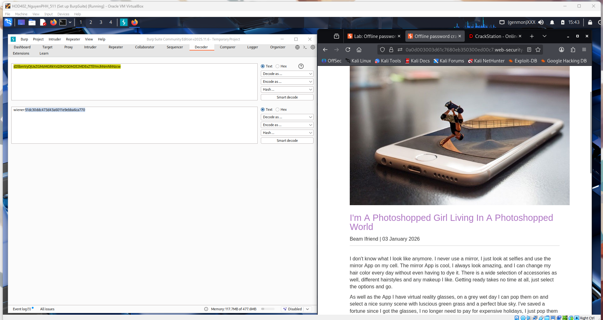
This image shows the attacker interacting with the blog after gaining unauthorized access. The comment field is being used to submit a script payload (<script>alert(1)</script>), demonstrating a potential stored XSS vulnerability in the comment functionality. This step highlights how account compromise can be combined with client-side attacks to further impact other users.
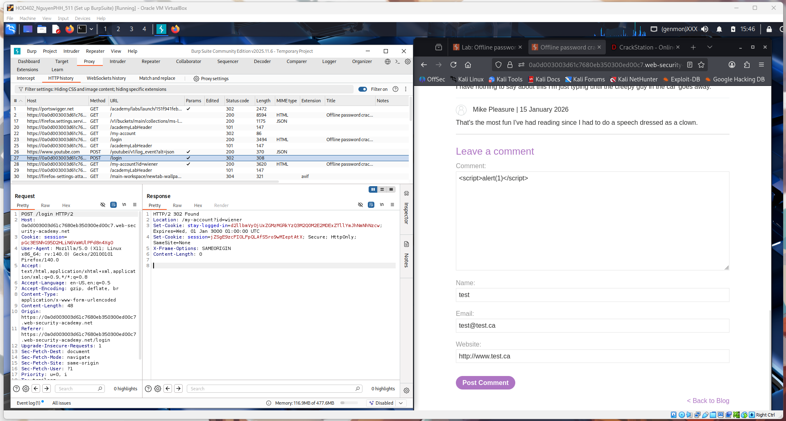
This image shows the server’s response after submitting the malicious comment. The page displays “Thank you for your comment! Your comment has been submitted.”, confirming that the input was accepted and stored. This indicates that the injected script may execute later when the comment is viewed, demonstrating a stored XSS risk.
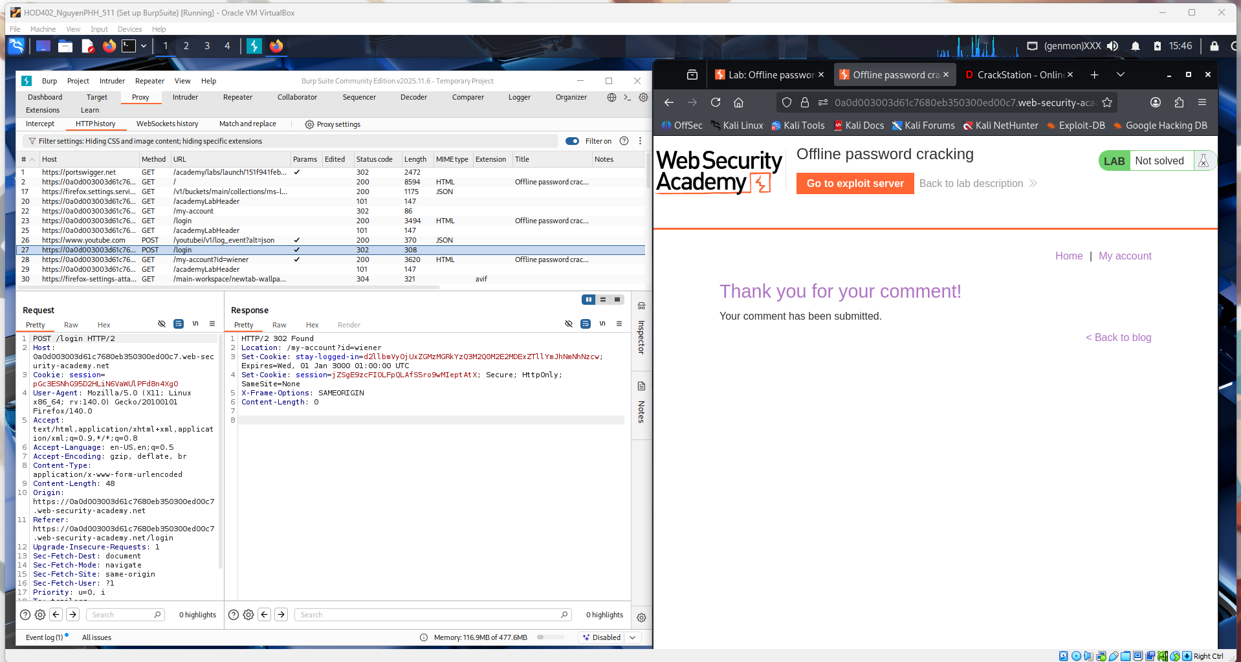
A JavaScript payload (<script>alert(1)</script>) in the comment field and the server stored it. When the page loaded, the script executed and triggered the alert box showing “1”. This confirms a stored XSS vulnerability.
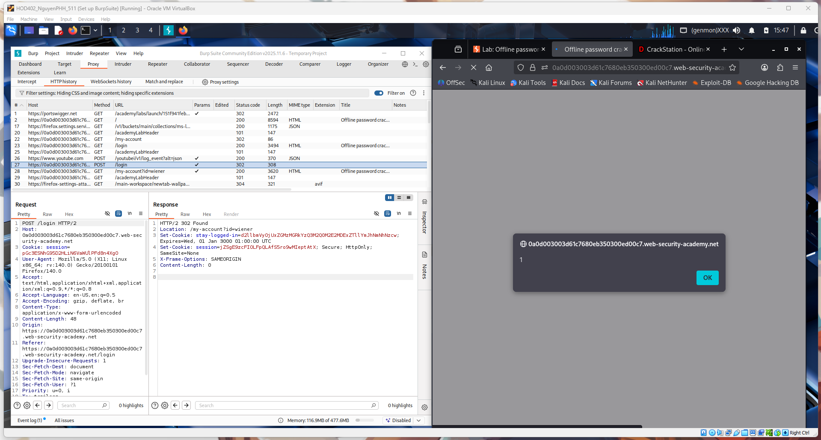

You submitted the payload <script>document.location</script>. If the script executes in the browser, it proves that user-supplied JavaScript is running on the page.
That confirms a Stored Cross-Site Scripting (Stored XSS) vulnerability — the app isn’t properly filtering or encoding comments, allowing attackers to inject scripts that run when others view the post.
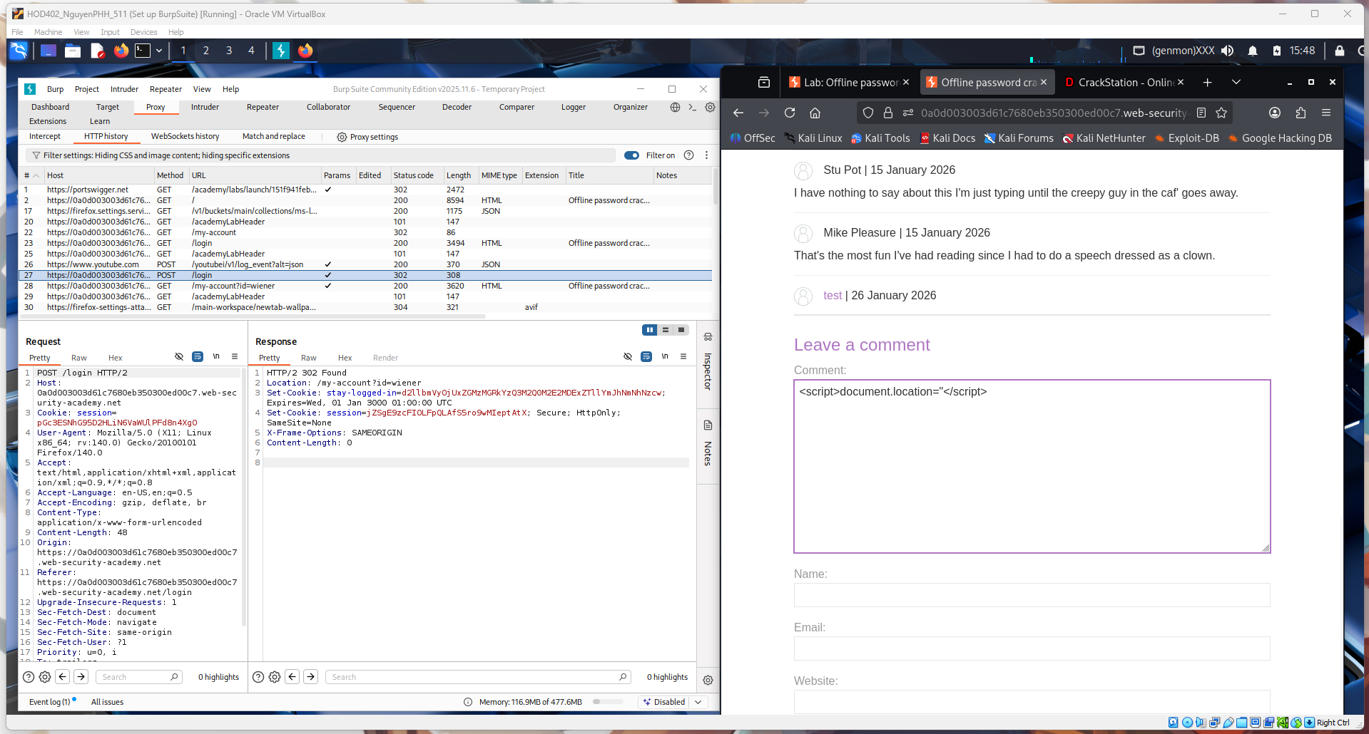

You are crafting a response at /exploit with Content-Type: application/javascript, which means the server will host a malicious JS file. This script will later be loaded by the victim’s browser through the stored XSS.
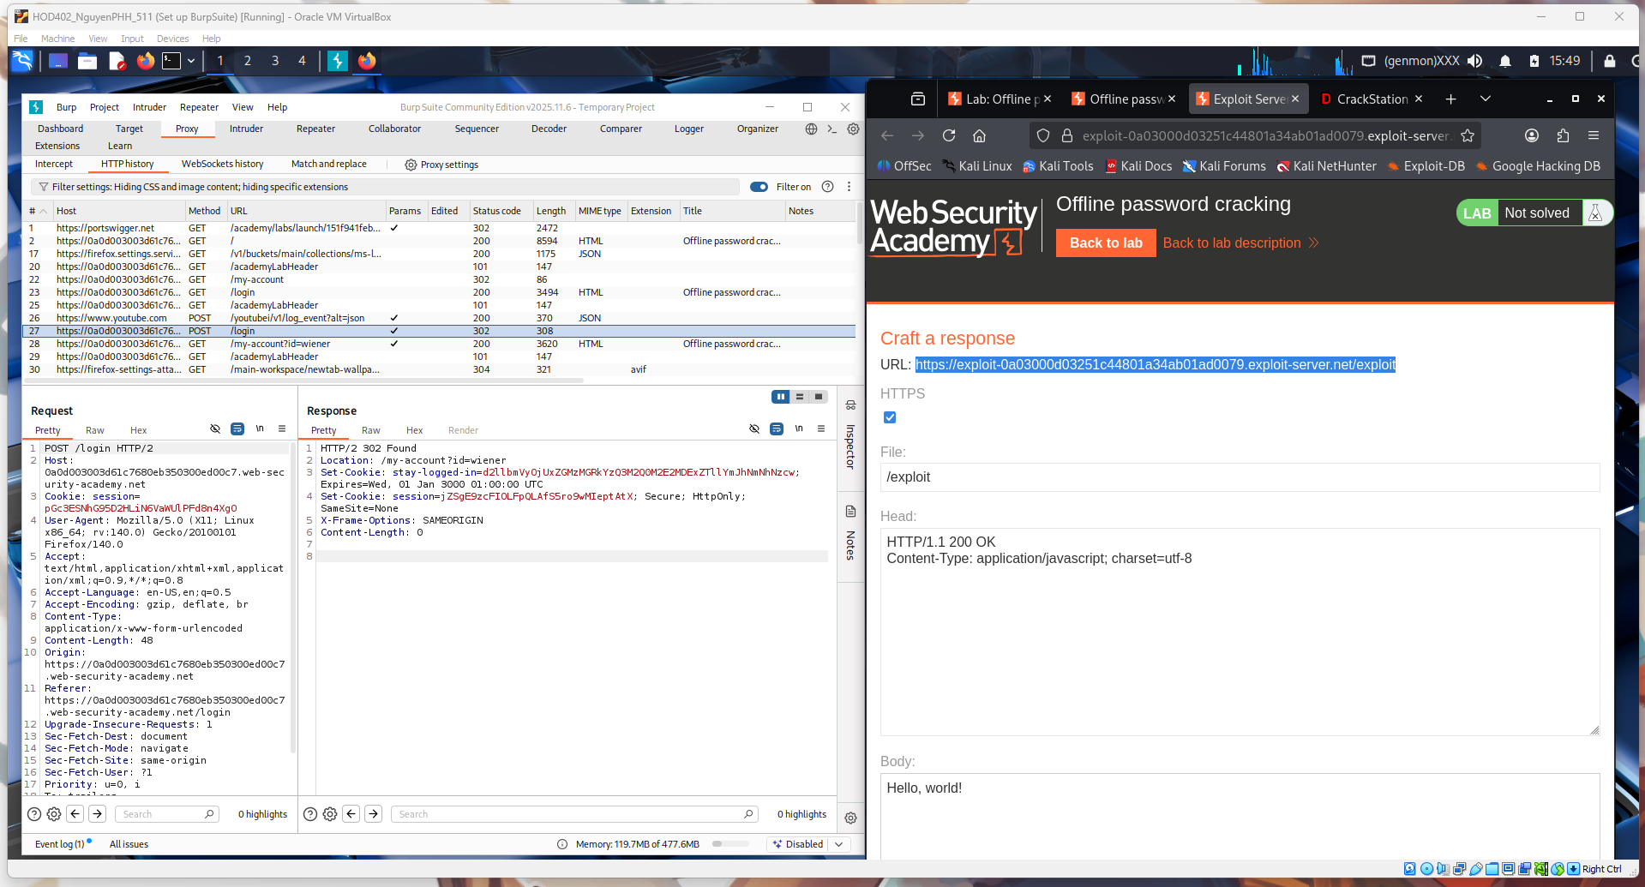
This screenshot shows the stored XSS payload being injected into the comment field.
The script uses document.location to redirect the victim’s browser to your exploit server URL, appending document.cookie. When an admin views the comment, their browser executes the script and sends their session cookie to your server.
So this step is the delivery stage of the attack — planting the malicious JavaScript that steals the victim’s session.
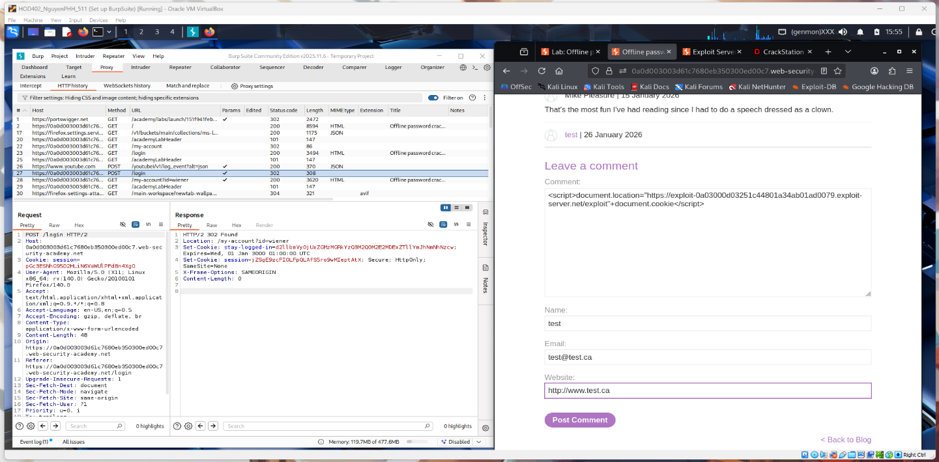

This image shows the comment successfully submitted after injecting the payload.
The “Thank you for your comment!” message confirms the malicious script is now stored on the server. That means any user (like the admin) who views the post will execute the JavaScript automatically.
So this step confirms the stored XSS is live and waiting for a victim to trigger it.
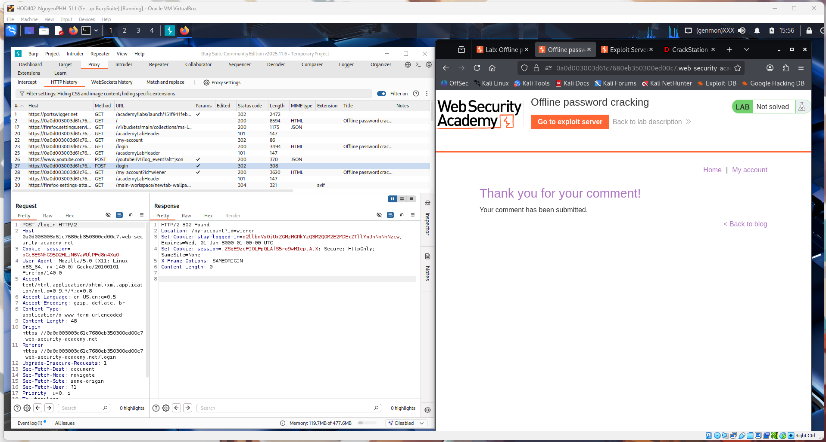
This screenshot shows the exploit server access log after the XSS payload executed.
You can see multiple HTTP GET requests coming from the victim’s browser to the exploit server, including a long URL containing encoded data — this is the exfiltrated cookie sent by the JavaScript payload.
That confirms the admin (victim) viewed the page, the stored XSS fired, and their session data was successfully stolen.
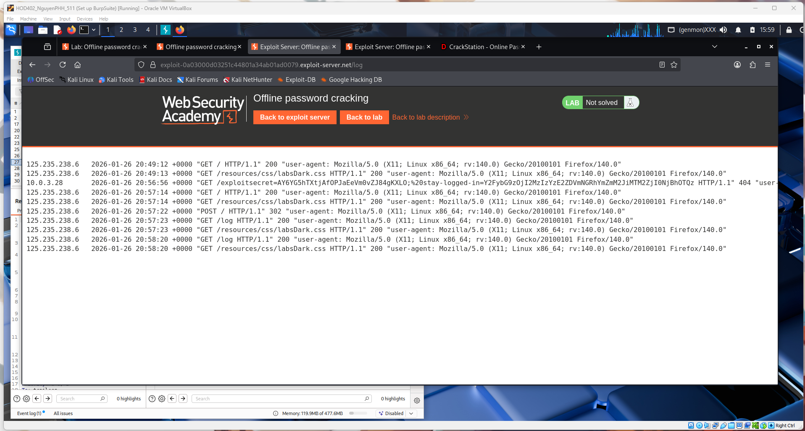
This log shows the moment the victim’s browser executed your XSS payload and contacted the exploit server.
The long request to /exploit?...stay-logged-in=... contains the URL-encoded cookie value, which was sent by document.cookie in your script. That means the browser ran the injected JavaScript and leaked the session cookie to your server.
So this confirms the attack worked: stored XSS triggered → victim visited page → cookie exfiltrated.
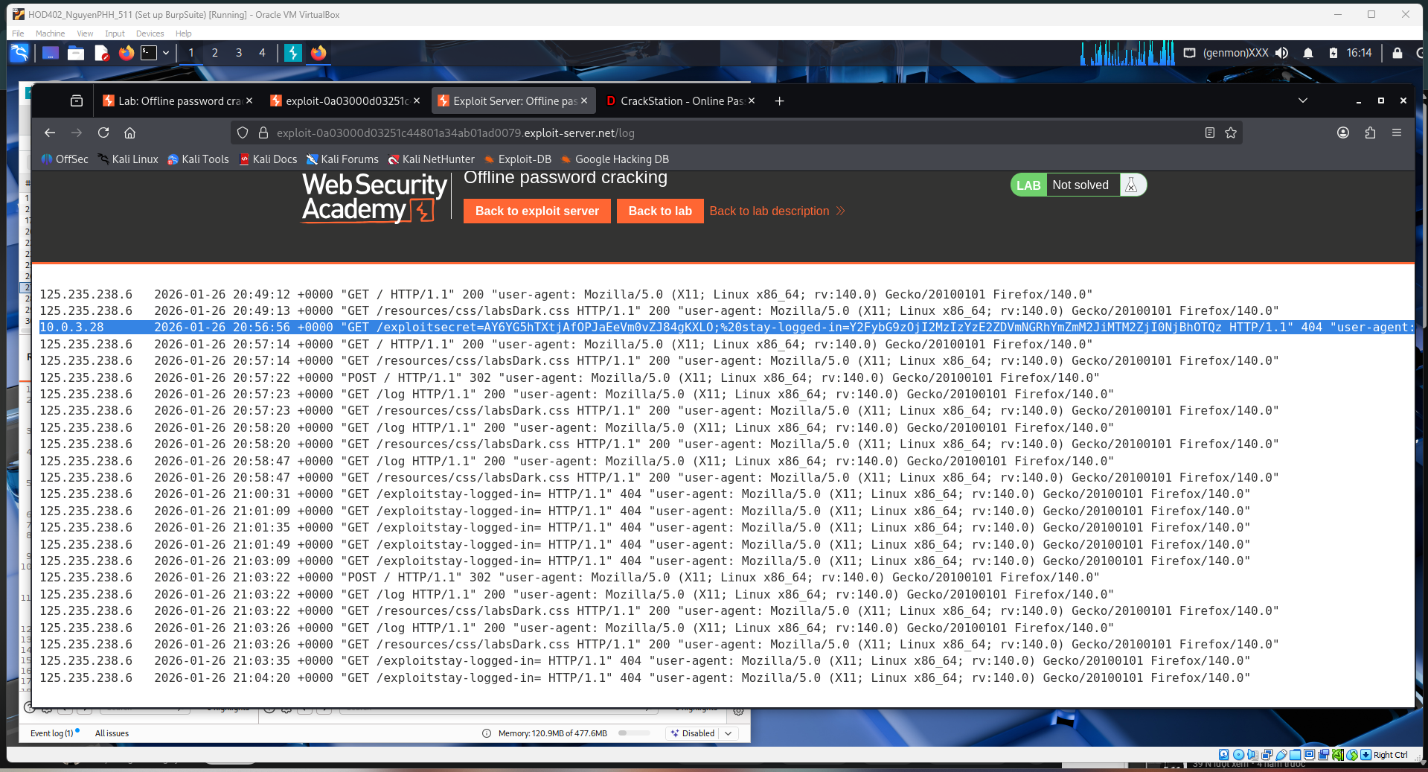

This screenshot is the exploit server access log showing the stolen data arriving.
The highlighted request to
/exploit?stay-logged-in=...
contains a long encoded value, which is the victim’s stay-logged-in cookie sent by your injected JavaScript.
Because the server received this request, it proves the stored XSS executed successfully and the authentication cookie was exfiltrated from the victim’s browser.
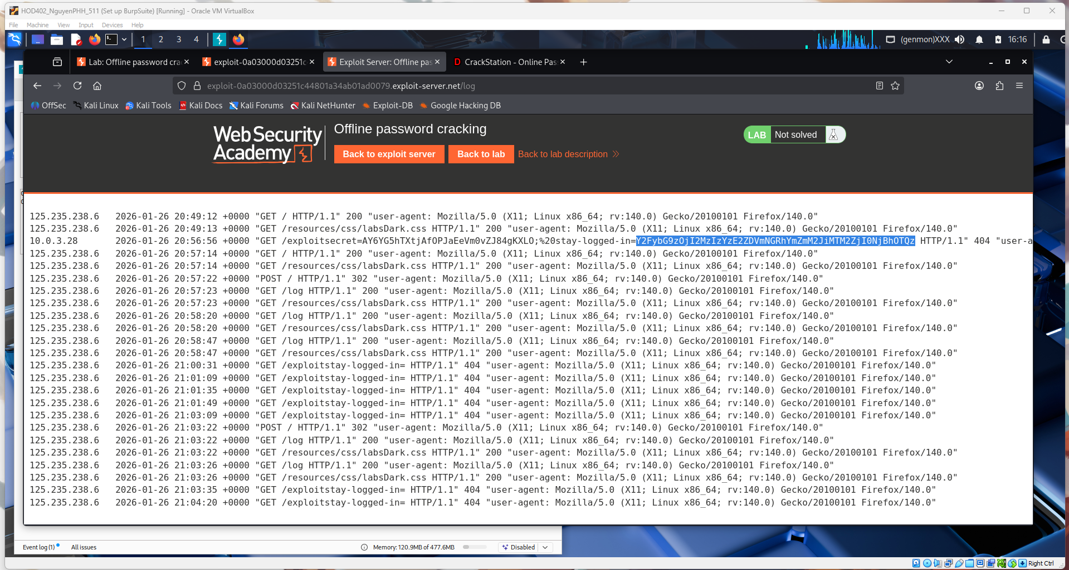

This image shows you decoding the stolen cookie.
On the right is the exploit-server log with the long stay-logged-in value captured from the victim.
On the left, you pasted that value into Burp Decoder, and after decoding, it reveals:
carlos:2633c165d4abf83b16f240a943
That means the cookie contains Carlos’s username + hashed password, which you can reuse to log in as carlos and solve the lab.
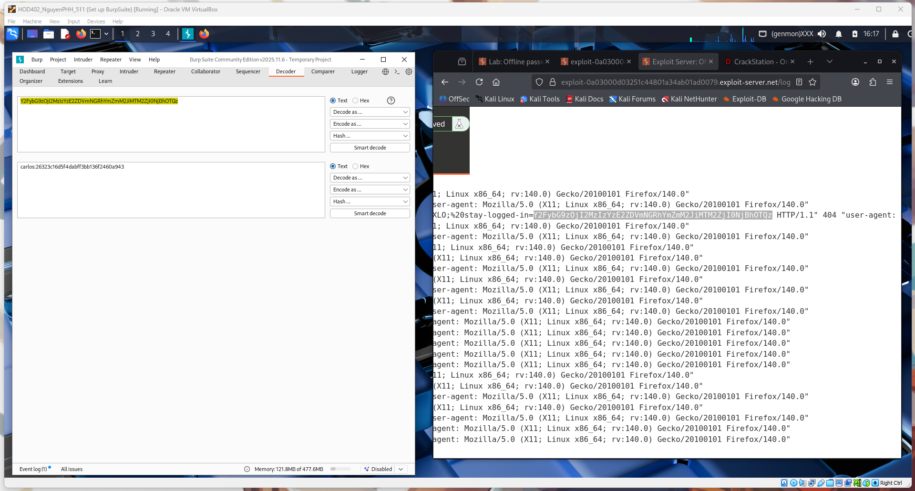

You decoded the cookie in Burp and got Carlos’s MD5 password hash.
Then you searched that hash on CrackStation and it revealed the real password: onceuponatime.
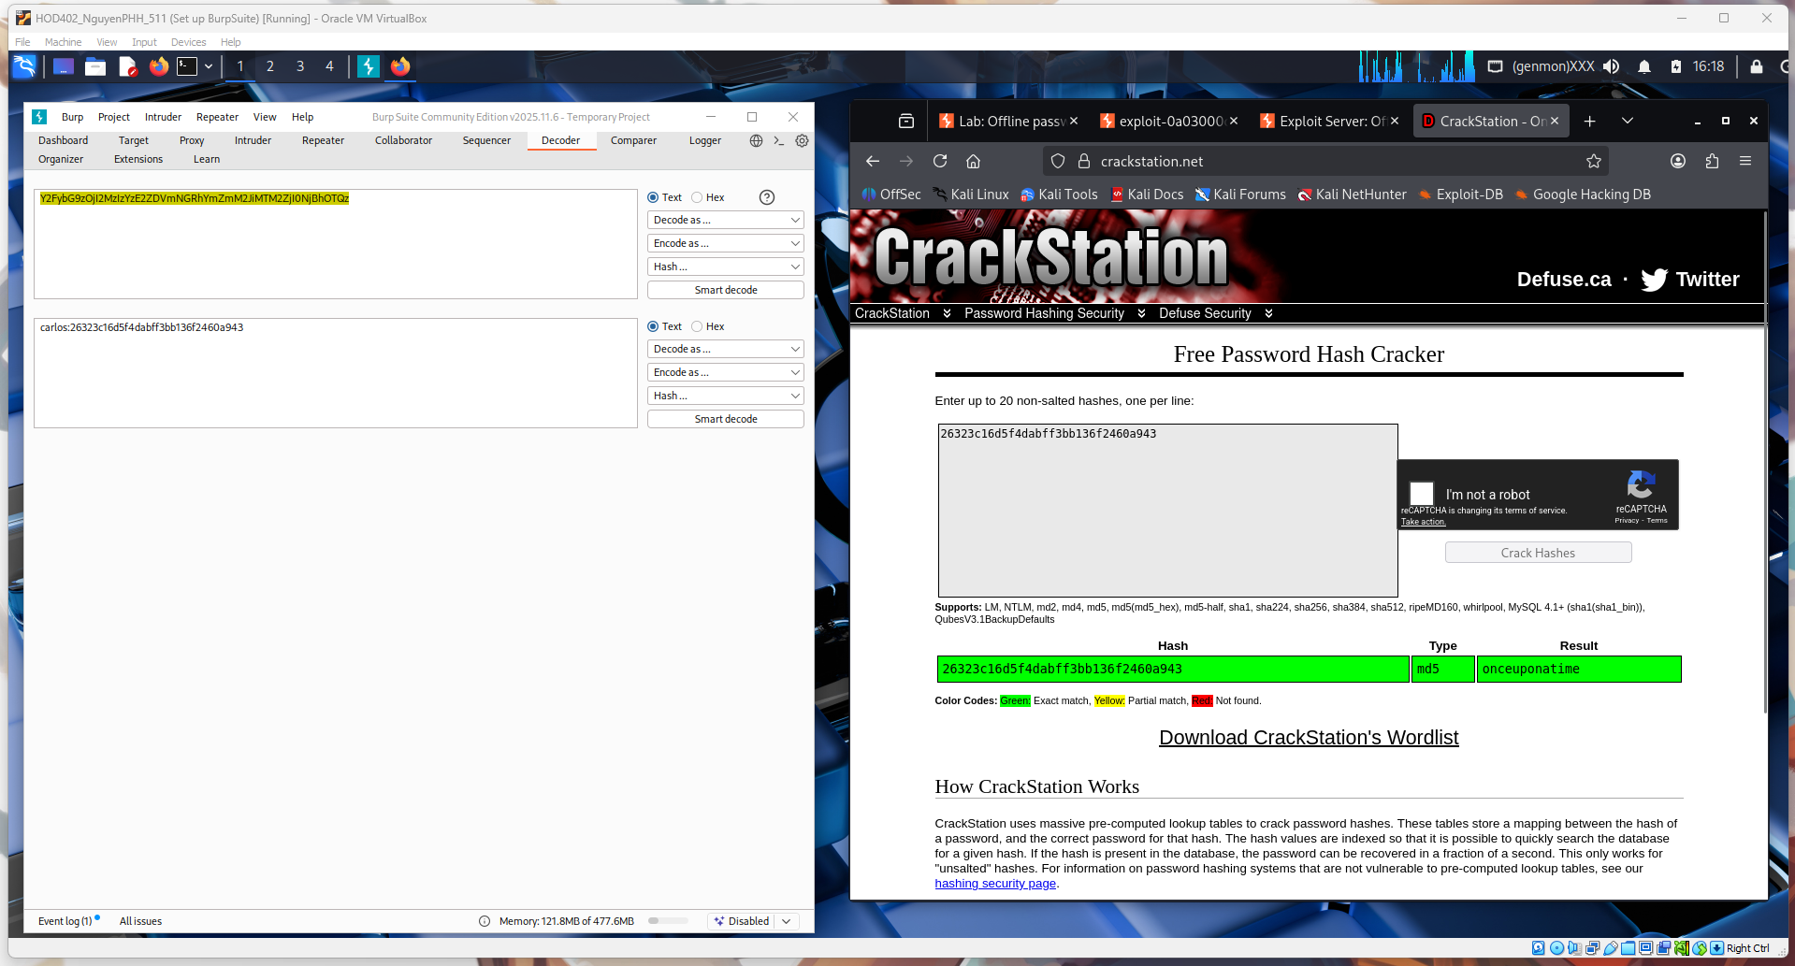
You used the cracked password onceuponatime to log in as carlos.
This confirms the hash you extracted and cracked was correct, completing the account takeover step.
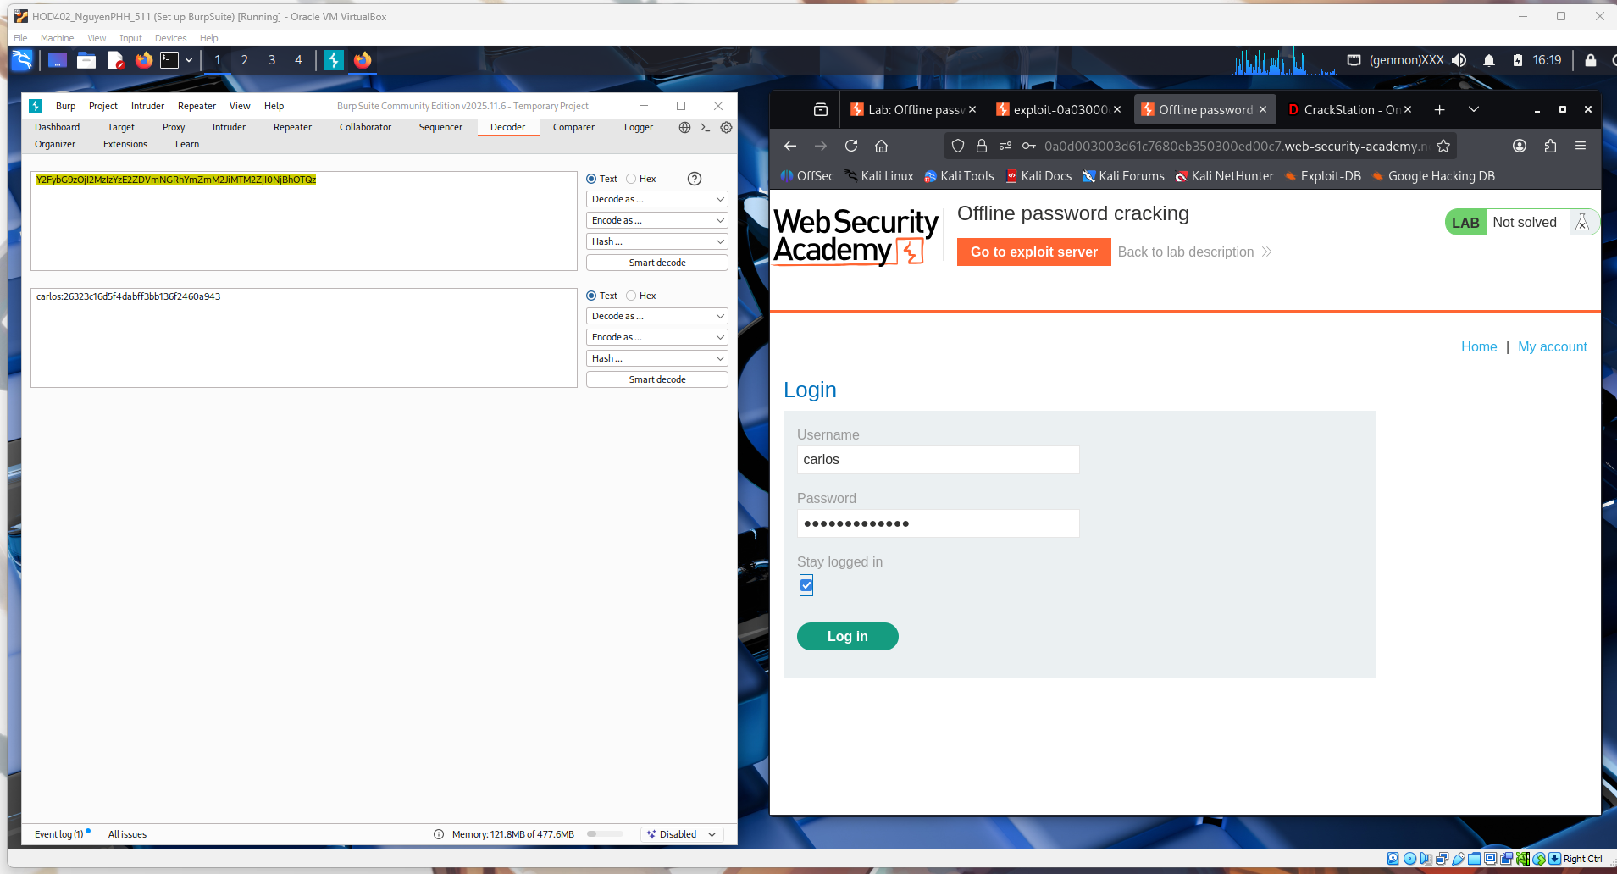

You are successfully logged in as carlos on the My Account page.
This proves the cracked credentials worked and you now have access to the victim’s account features (email change, account actions).
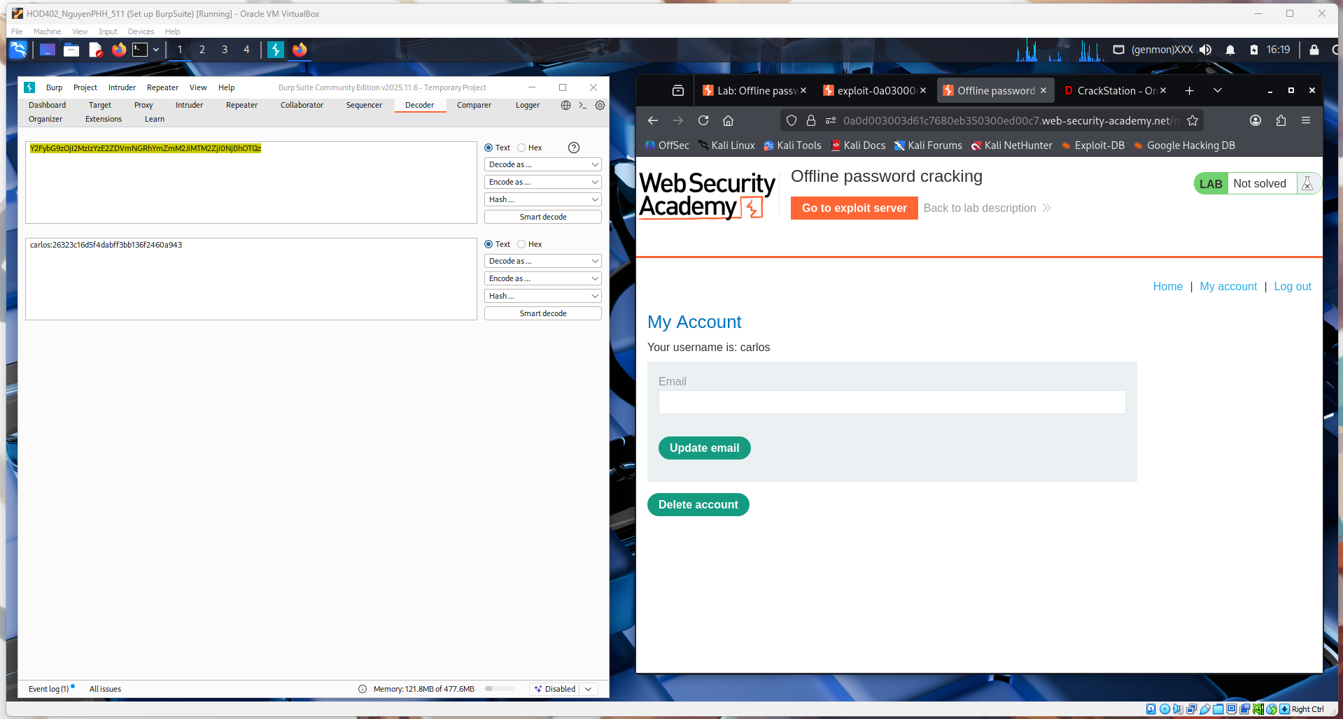
This screen is the account deletion confirmation page.
The app asks you to re-enter Carlos’s password to verify identity before permanently deleting the account.
Submitting the correct password and clicking “Delete account” completes the lab objective.
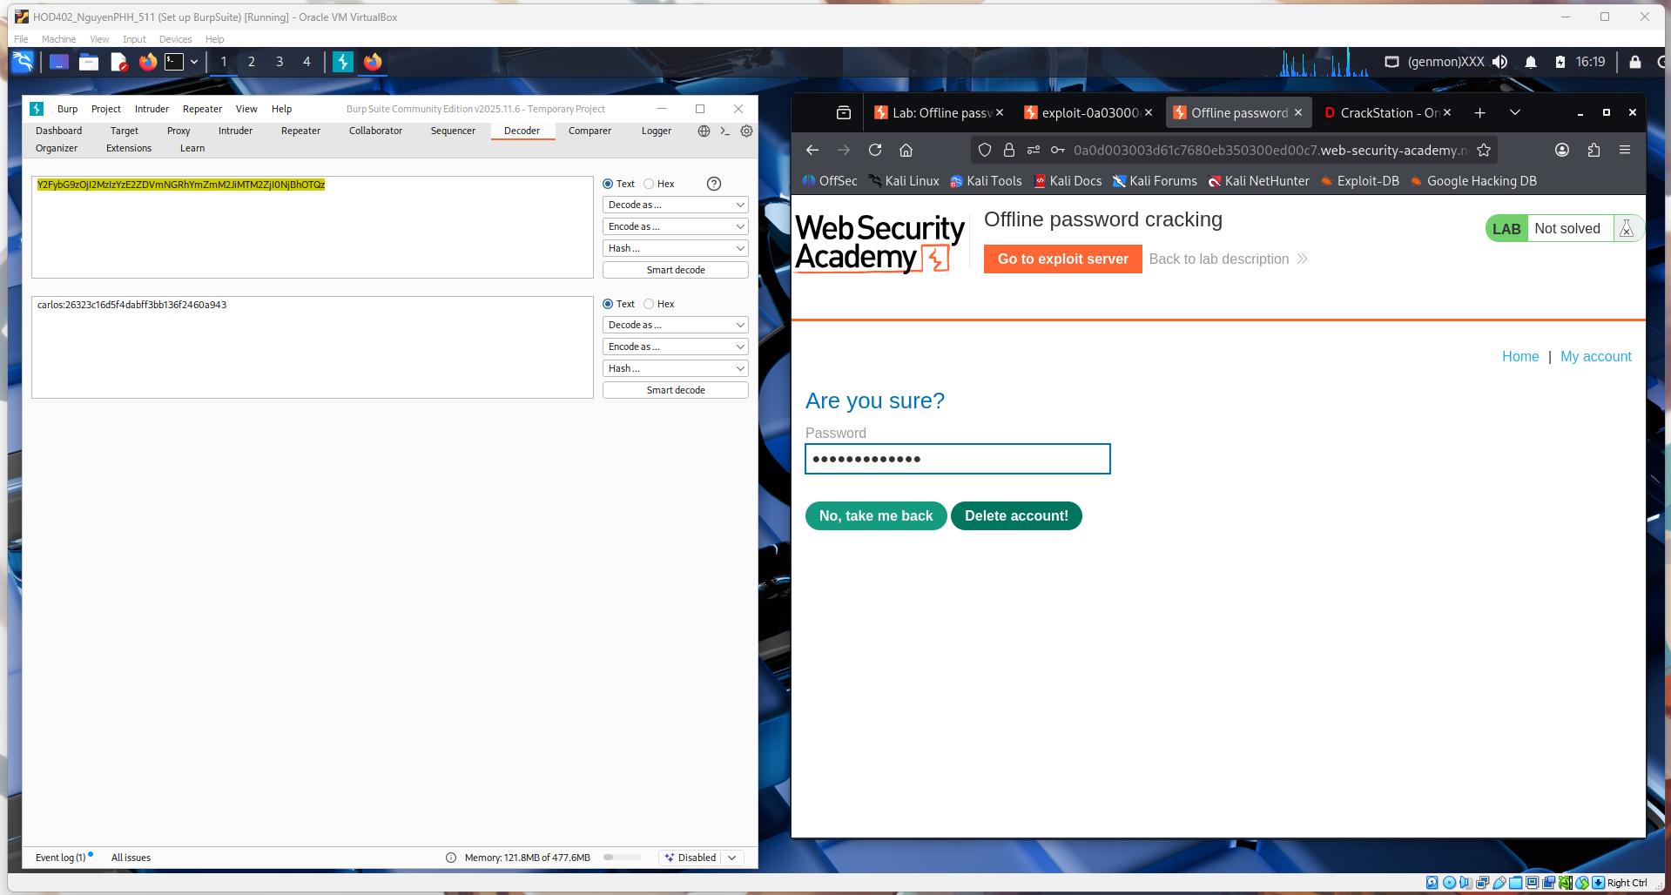

This screenshot shows proof the lab is completed:
- The banner “Congratulations, you solved the lab!” means the exploit worked successfully.
- Top right shows LAB: Solved → PortSwigger marked it as finished.
- You’re logged in and the account actions went through (the cracked password was valid).
On the left, Burp Decoder shows the MD5 hash you cracked → that password was reused in the app, which is the whole vulnerability:
Offline password cracking + password reuse.
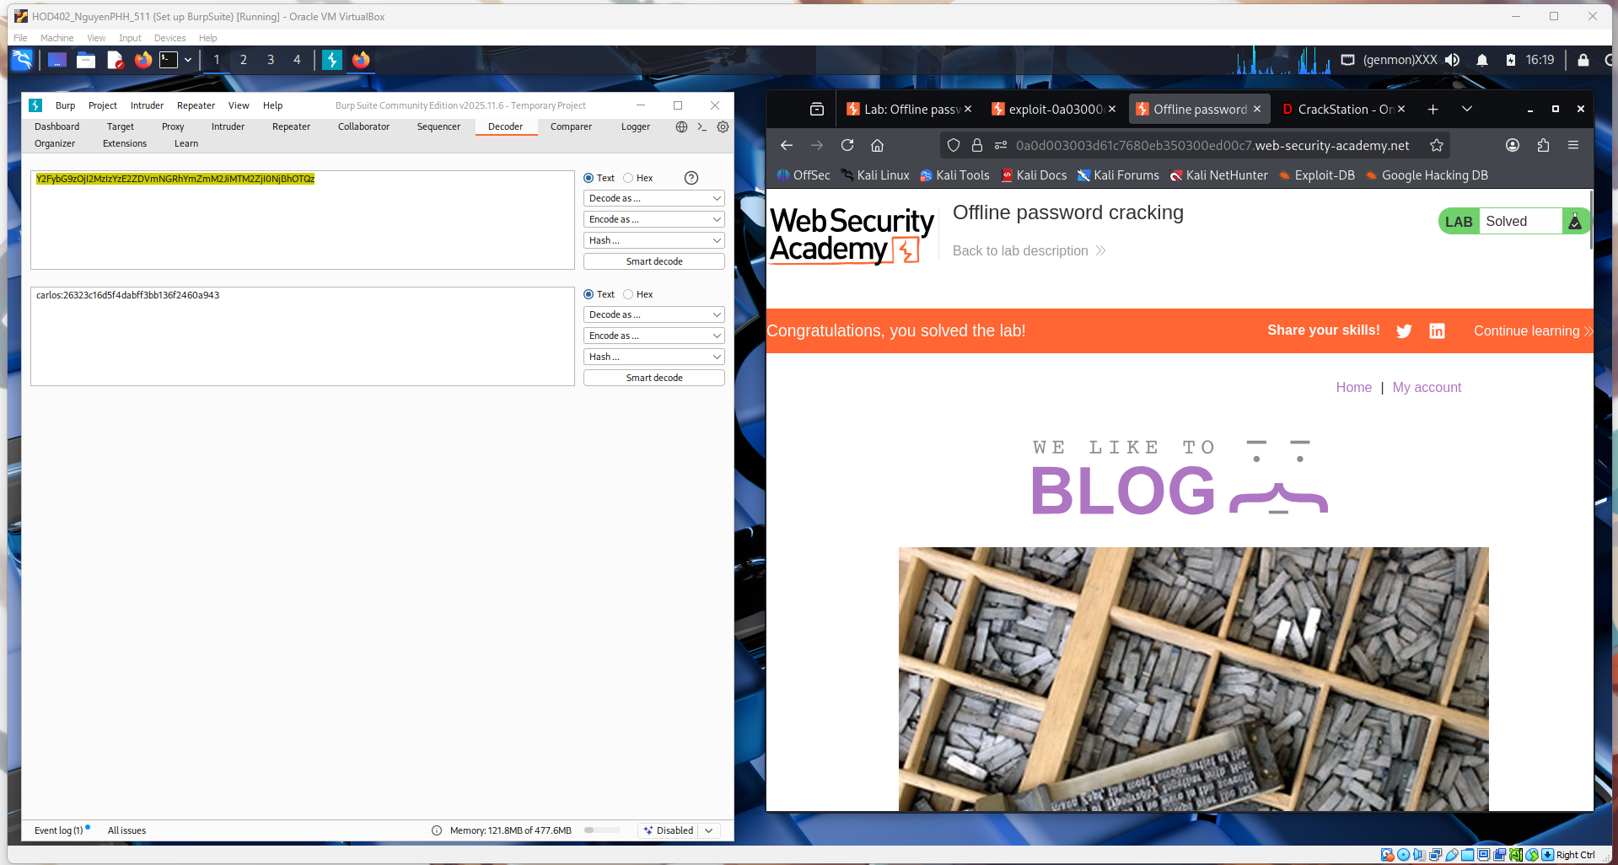
Conclusion – Offline Password Cracking:
In this lab, we demonstrated how stolen password hashes can be cracked offline without interacting with the target system. By obtaining the hashed password and using cracking techniques (such as dictionary or brute-force attacks), we were able to recover the original password. Because the user reused the same password on the actual website, this allowed full account access.
This shows that weak passwords and password reuse create serious risks. Even if passwords are stored as hashes, attackers can still recover them if the hashing method is weak and the password is simple. Strong hashing algorithms, salting, and unique passwords for each service are essential to prevent this type of attack.

